**Examination of an externally loaded leaking flange joint for leaking using finite element analysis**

**Chidhambara Ayyanar, Sam Gilbert, Michael Regan,** & **Bijoy Verghese**

Department of Mechanical Engineering, University of Illinois at Urbana Champaign

DOI:10.1234/12345678ABCD123

**ABSTRACT**

Bolted flange joints heavily utilize gaskets to create a seal in pipelines. Not only do gaskets experience high operating pressures and external loads, but also elemental exposure affects the integrity of the gasket seal. When seal performance fails, alternative flange joints must be examined. This investigation explores the feasibility of replacing an existing spiral wound gasket on a flange joint with a ring type joint for high pressure pipelines evaluated with Abaqus and with author-created MATLAB FEM solver.

**Keywords**: flange joint, finite element analysis

**1.0 Introduction**

A leak in a flange joint was discovered in an offshore high-pressure gas pipeline feeding an onshore facility. Investigation of the joint identified minor gas leakages in the joint’s spiral wound gasket (Figure 1.1), a component not recommended to be utilized under high pressures and high external loads. An additional root cause of the gas leakage was identified as soil settlement across the pipeline, resulting in a high differential external load on the flange joint. Although leakage risks were mitigated via reduction in gas operating pressure and the installation of a temporary clamp on the joint, a long-term solution was needed.

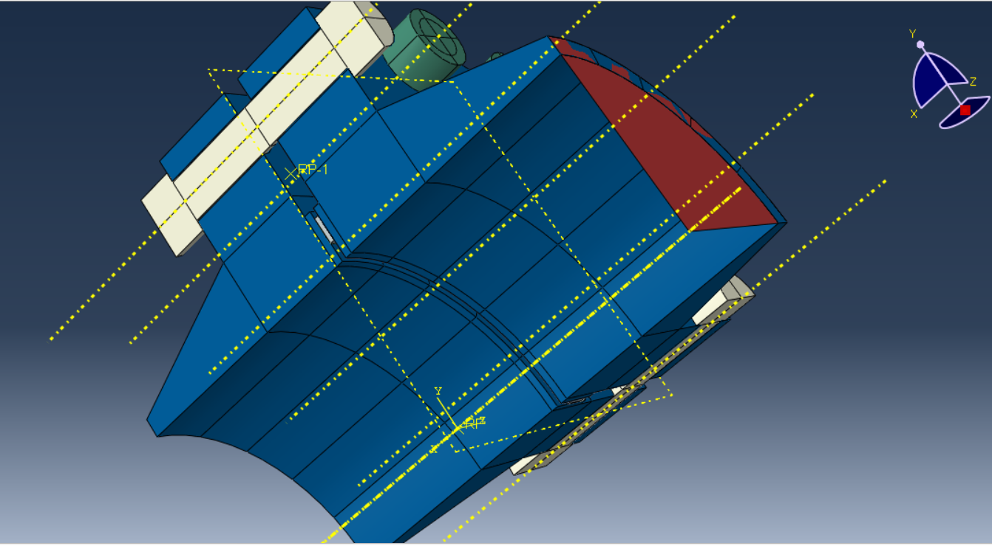

Figure 1.1: Model representation of existing joint and its spiral wound gasket

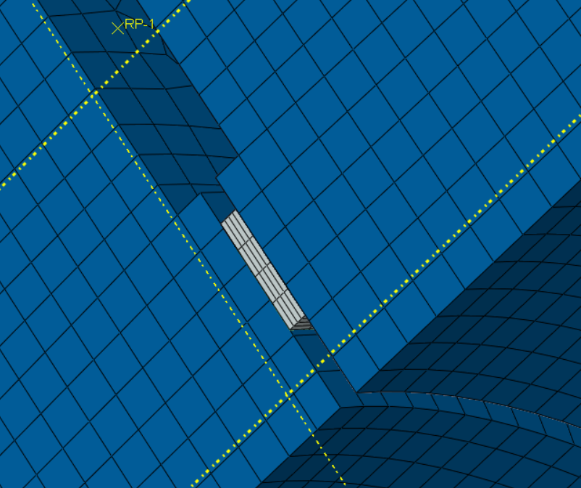

Figure 1.2: Close-up of model representation of existing spiral wound gasket

This investigation explores the feasibility of replacing the existing flange joint and its existing spiral wound gasket (Figure 1.2) with a ring type joint (Figure 1.3).

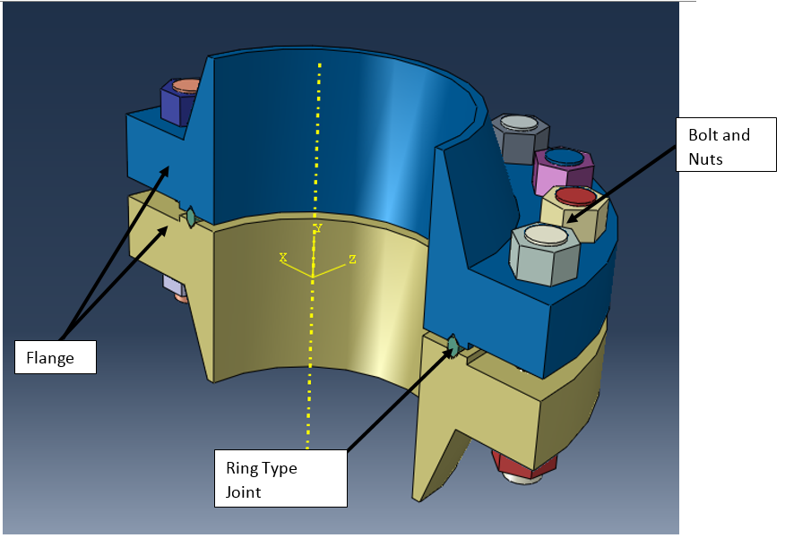

Figure 1.3: Proposed ring type flange joint

The pipeline runs over a hundred kilometers in length and is 12” in diameter. The minor gas leakage was observed at an operating pressure of 60 bar. Further reduction of the operating pressure to 40 bar initially indicated no further leakage, however during verification, gas leakage was still observed at 29.6 bar operating pressure.

**2.0 Geometry**

The neck of the flange was 12 inches in diameter.

**CK**

**3.0 Material properties and data**

Original materials

CK

Both models utilized SS316 as the representative material for the gasket of the proposed RTF.

**4.0 Discretization and meshing**

Brick element or Gasket element (8 node)

CK

meshing

**5.0 Boundary conditions and loading conditions**

**CK**

***5.1 Pressure load***

Max/min operating pressure: 100bar/0barg

CK

The solvers modeled a 2D slice of one side of the gasket and modeled the contact force as an equivalent pressure.

***5.2 Bending moment***

Mresultant = 78,639Nm

CK

The solvers modeled a 2D slice of one side of the gasket and modeled the contact force as an equivalent pressure.

***5.3 Temperature***

Max/min temperature 60/0 degrees Celsius

**CK**

**6.0 Assumptions and limits**

**7.0 Finite element analysis**

This investigation performed two forms of analyses. The team coding their own solver using Matlab to determine XXXXX. The second solver utilized Abaqus. For both solvers, the team modeled a two dimension slice of one side of the proposed gasket of the ring type joint (RTF) and modeled the contact force as an equivalent pressure.

Total number of nodes.

6 steps

Discretization, stiffness matrix, etc.

***7.1 3D Abaqus solver***

**Brian**

Model a 2D slice of one side of the gasket and model the contact force as an equivalent pressure

Model loading and unloading cycles of pressure of the gas and answer if the gasket will leak or not

FEM formulation

Derivation of element stiffness matrix [k]

using variational or weighted residual approach

FEM solution

(temp distribution, deformed structure, etc.)

Linear elastic

Post-Processing

Stress field

Maximum stress

Maximum temperature

Convergence of FEM model

Assumptions **Brian**

No specific bolt loads (modeling all as pressure)

Potential function or ODE

Bending

**3d model results bijoy**

***7.2 2D Abaqus solver***

A two-dimensional (2-D) model was created of the proposed ring-type flange (RTF) joint on Abaqus finite element analysis software. The flange was considered to be symmetric to create a 2-D slice of the cross section of the flange joint and designed with 4-node bilinear plane stress quadrilateral elements (CPS4) as shown in Figure 7.2.1.



Figure 7.2.1: 2-D Abaqus FEA model of proposed flange joint

Two loads from the bolts on the flange were modeled as mechanical forces, and the gas within the pipeline was modeled as a uniform pressure on the inside surface of the proposed flange joint as shown in Figure 7.2.2. The contact forces of the gasket were modeled as an equivalent pressure on the surface of the RTF.



Figure 7.2.2: Loading conditions of 2-D Abaqus FEA model of proposed flange joint

Under such loads as previously mentioned in the loading conditions, the maximum displacement of the flange occurred at the piece’s outer edges where the bolts were loaded as shown on the plotted contours in Figure 7.2.3.



Figure 7.2.3: Displacement results of 2-D Abaqus FEA model of proposed flange joint

As shown on the plotted contour in Figure 7.2.4, the maximum magnitude of von Mises stress occurred at the fillet of the proposed ring flange joint.



Figure 7.2.3: Displacement results of 2-D Abaqus FEA model of proposed flange joint

Utilizing the CPS4 element resulted in smooth stress and displacement field contours across the 2-D Abaqus FEA model. With the maximum displacement at the outer edge of the flange where the bolt loads occur, the proposed ring gasket experience a compressive load at the outer edges of the spiral wound gasket for a tight seal in the pipeline.

***7.3 2D Matlab solver***

The assignment required that a program be written to solve the projects finite element problem, however several simplifications had to be done to the original goal of modeling a gasket between a flange. Ultimately it was decided to model a two-dimensional cross section of a flange, gasket and bolt, and only model the pressure of the bolt. In addition to being able to more directly leverage techniques taught in the course, it will provide an interesting comparison to the more thorough and complex model of Abaqus.

From a software architecture point of view, a finite element solver program was written was tailored for this specific simplified flange problem in MATLAB. Although much of the code written is specific to this problem, there was a goal to make the code applicable to as many FEM problems as possible. An object-oriented approach was chosen in an attempt to keep as much of the program as general. Often a class would wrap a more primitive MATLAB construct, such as the GlobalStiffnessMatrix type wrapping a sparse matrix. These helper types would also include functions to handle common operations, such as an AddLocalStiffnessMatrix function on the GlobalStiffnessMatrix. Different element types were developed, however only the base Element type and the Triangular3Node2DElement classes were ultimately used for this problem.

The two-dimensional cross section of the flange, gasket and bolt were originally exported from Abaqus, and from that a mesh was created in GMSH. There were several issues with this process. First, the size of the element out of GMSH was 1/100th of what it was in Abaqus. This was corrected in the MATLAB code where, when the mesh was read in, all of the node coordinates were multiplied by 100. Also the export process did not take into account any curves and fillets on the model.

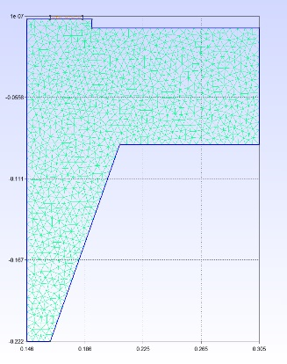

Figure 7.3.1: Mesh for Finite Element Program

One final issue was that the MATLAB FEM solver was not able to enforce continuity between the flange and the gasket. As such, the gasket was ignored in the analysis.

For simplicity, 3 node triangular elements were used for the mesh, with a maximum unitless size of 0.005. Combined with the material properties used in Abaqus, the local stiffness matrices were derived. Instead of modeling the contact stresses of the bolts, equivalent forces were calculated with equations and values from the manufacture of the flange:

<TODO actual pretty equations>

Equivalent Pressure = (4*BoltForce/EffectiveGasketDiameter **2+ 16 * Bending Moment on Flange/EffectiveGasketDiameter**3) / 6894.7

Equivalent Force = Equivalent Pressure * span of bolt forces

With the magnitudes of the forces evaluated, they were applied to the node closest to the center of each area the pressure was being applied. The global stiffness matrix wrapped an instance of a sparse matrix that is built into MATLAB, and the global load vector was assembled. For this problem, the pressure was modeled as a boundary condition on the left side of the flange preventing the flange from moving in the X direction. To account for symmetry the top of the gasket was fixed in the y direction. The boundary conditions were hard-coded into the program, eliminating rows and columns for node elements that were fixed or where the axis of symmetry cut the cross section. The displacements of the remaining nodes was found by inverting the remainder of the global stiffness matrix and multiplying it with the load vector that remained after eliminating rows due to boundary conditions. The reaction stresses and strains where then computed and plots of the stress and displacements were generated.

In order to model the ramp up of the pressure, the main algorithm of evaluating displacements was done in a loop where the pressure was increased in increments of 1/10 of the maximum load. This resulted in a linear growth in the displacement up to the maximum of 0.3428. The results for the maximum loading were reasonably close to the Abaqus results, being only 5.4% less than the maximum displacement evaluated in Abaqus.

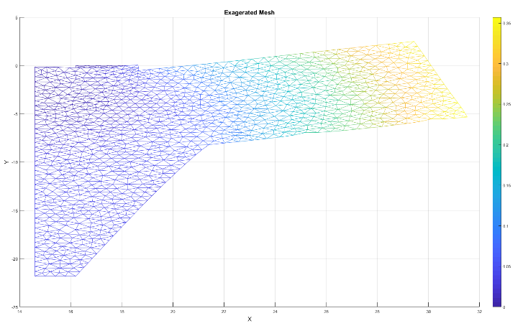

Figure 7.3.2: Mesh under load, displacements exaggerated by a factor of 100

The stress forces on the flange had a similar distribution as the Abaqus model, mainly showing large stress at the lower convex corner and at the boundary condition where the gasket would be. However the values were significantly lower than what Abaqus evaluated, being 68% off from Abaqus’s value of 406.2. It is strongly suspected that there is an error in the written FEM program causing this discrepancy.

***7.4 Comparison between code and Abaqus results***

2 pages

**8.0 Discussion**

***8.1 Discussion and analysis of results***

Would the flange leak? No

Min stress of gasket is 69 MPa

**Bijoy**

***8.2 Implications for design***

Direct application for proposal to replace existing flange joint and spiral wound gasket

**Bijoy**

**9.0 References**